STudent Assessment Submission and Declaration

When submitting evidence for assessment, each student must sign a declaration confirming that the work is their own.

Student Name:  MN. Sihanas/1030371 |  | Assessor Name:  Eng. A.L. Jubailah Begum
Issue Date:  16.05.2024 | Submission Date:  11.08.2024 |  | Submitted on:  18.08.2024
Programme:
Pearson BTEC HND in Computing
Unit no. & Title: 04. Database Design and Development
Assignment title:
Database system for “Dickwella Beach Hotel and Resort”

Plagiarism
Plagiarism is a particular form of cheating. Plagiarism must be avoided at all costs and students who break the rules, however innocently, may be penalised. It is your responsibility to ensure that you understand correct referencing practices. As a university level student, you are expected to use appropriate references throughout and keep carefully detailed notes of all your sources of materials for material you have used in your work, including any material downloaded from the Internet. Please consult the relevant unit lecturer or your course tutor if you need any further advice.

Student Declaration

Student declaration

I certify that the assignment submission is entirely my own work and I fully understand the consequences of plagiarism. I understand that making a false declaration is a form of malpractice.

Student signature: 1030371@bcas.ac Date: 18.08.2024

Assessment Tracking

Programme: | HND Computing | Student Name: | MN. Sihanas/1030371
Unit No. & Title: | Unit 4: Database Design and Development | Assessment Issue Date: |  | Submission Date:
Assessor Name: | Eng. A.L. Jubailah Begum | Completion Date: |  | IV Signature: | nismy@bcas.lk

Tasks | Sub tasks | Criteria Targeted | Date Issued | Hand In Date | Formative  Feedback | Resubmission Date
01 | 1.1 | P1 | 16.05.  2024 | 21.05. 2024 | 22.05. 2024 | 25.05. 2024
01 | 1.2 | P1, M1
02 | 2.1 | P2 | 16.05.  2024 | 05.06. 2024 | 06.06. 2024 | 10.06. 2024
02 | 2.2 | P3
02 | 2.3 | P3, M2, M3, D2
03 | 3 | P4, M4 | 16.05.  2024 | 19.06. 2024 | 20.06. 2024 | 25.06. 2024
04 | 4.1 | P5, M5, D3 | 16.05.  2024 | 10.07. 2024 | 11.07. 2024 | 15.07. 2024
04 | 4.2 | M1, D1

Assignment Brief
Unit 4: Database Design and Development

Student Name & Zoho ID: | MN. Sihanas / 1030371
Programme: | HND Computing
Unit Number and Title | Unit 4: Database Design and Development
Academic Year | 2024
Batch | Batch 22
Unit Assessor | Eng. A.L. Jubailah Begum
Assignment Title | Database system for “Dickwella Beach Hotel and Resort”
Issue Date | 16.05.2024
Submission Date | 21.07.2024
Submission Format
Pdf document of the report, database log files, SQL files, GUI .exe file and dataedo documentation file.
Unit Learning Outcomes
LO1 Use an appropriate design tool to design a relational database system for a substantial problem
LO2 Develop a fully-functional relational database system, based on an existing system design
LO3 Test the system against user and system requirements
LO4 Produce technical and user documentation.
Transferable skills and competencies developed
Determining user and system requirements, entity relationship modelling, referential integrity, data normalisation to third normal form, database and platform options for system development.
Implementation of the physical data model based on the logical model and linking code to data sets, Data manipulation using appropriate query tools, including complex queries to query across multiple tables and using functions and formulae. Database maintenance and data manipulation: inserts, updates, amendments, deletions, data backup and recovery.
Test procedures to be used: test plans, test models, e.g. white box, black box; testing documentation.
User documentation, including how to use the system, outputs produced by the system, menu operations and other functions.
Vocational scenario
Database System for “Dickwella Beach Hotel and Resort”

The management is proud of new owners of Dickwella Beach Hotel and Resort with its 100 en-suite rooms, bar and restaurant. They have asked you to develop a system that will manage the room booking processes, keep details of additional services that guests purchase during their stay and produce the final bill for a stay. The Manager describes the processing involved as follows:

- • A booking or visit starts with a room request coming in from a potential guest. We take details of the reservation request and search for availability by looking in the desk-diary to see which rooms are available for the required Dates. We have 20 single, 60 double and 20 family rooms that can accommoDate up to 5 persons in each.

- • If the required rooms are available we create a record of the reservation and include details of the room allocated to the reservation, start and end Dates and the number of guests staying in the room. At this stage we also check to see if the potential guest has stayed with us before or not. If they have, we find their details, check they are still accurate and then add their details to the reservation. If they haven’t stayed with us before, we take the Name of the guest making the reservation and their contact details and add these to our records.

- • If a guest wants to reserve more than one room we create a separate reservation record for each room reserved.

- • In reservation Guest should make payment for reservation.

- • When guests arrive at the start of their stay, we find their reservation and personal details, checking that their personal details are still correct and updating them as necessary. We then book them in for their stay, we call this an ‘Occupancy’. Local laws require that we record the Names and age of all guests and which room they are staying in.

- • We provide a restaurant and theatre booking service for our guests. This process involves little more than a telephone call to the organization and a verbal agreement being reached between the Hotel and the organization.

- • During their stay at the Guest House guests may purchase or hire additional services and products from us, such as newspapers, cycles, maps, food and drinks. We need to record all of these so that we can Charge for them at the end of the stay.

- • At the end of their stay guests request their final bill. We would like the system to calculate and produce this final bill. Reservation payment will deduct from the full payment. We then give it to the guest so that payment can be made. We keep a record of how much each stay in a particular room was billed for so that we can calculate income per room over a given period of time.

- • Guest can cancel the reservation before the reservation start Date. In cancellation the payment for reservation will not be refunded.

- • For each room a room boy and waiter are assigned. Room boys and waiters can provide services for many rooms.

- • In the event of Guest dissatisfactions about the rooms and services, they can complain to the manager of this hotel. This complains are recorded for further actions.

Assume you are appointed as a Database Administrator for Dickwella Beach Hotel and Resort and it is your responsibility is to design a database system for Dickwella Beach Hotel and Resort.

Assignment activity and guidance
Task 1

Task 1.1

Analyse and design a relational database system for Dickwella Beach Hotel and Resort with clear explanations and indicate the designing steps (Conceptual, Logical, and Relational Mapping). Make Any Valid Assumptions.

Use Microsoft Visio tool or any other tool to visualize the ER Model.

Task 1.2

- Create at least four interrelated tables for the above designed ER diagram, with clear statements of user and system requirements.

Give at least five rows for each table. Data entries to the tables can be your own assumed values. Evaluate the data validations on the data that you insert.

- Apply the Normalization rules on the above created tables up to third normal form. Mention each step to be followed along with the rules. The primary keys and the foreign keys must be indicated clearly.

Task 2

Task 2.1

Develop the physical relational database by creating the tables for the above designed ER Model with MSSQL Server. The tables created for above task can be utilized.

Identify and enforce all necessary constraints on the tables which include primary key, foreign key constraints and domain constraints etc.

Task 2.2

Implement the query language to insert data to the above created tables. So as to show your knowledge in SQL apply the queries to update and delete.

Task 2.3

- Implement complex queries in the above created tables to retrieve meaningful data and make the data entry very easy for the users.
Note: use the comment making Facility in the MSSQL Server when querying to indicate your step by step process clearly.

- Make sure that you create a database system which includes system security and database maintenance.

- Assess whether meaningful data has been extracted through the use of query tools to produce appropriate management information.

- Evaluate the effectiveness of the database solution in relation to user and system requirements and suggest improvements.

Task 3

Task 3

Critically review and test the developed database system against user and system requirements. Address your findings, errors and problems encountered in implementing the database including test plan and the possible test cases.

Note: Test procedures to be used: test plans, test models e.g. white box, black box; testing documentation.

Task 4

Task 4.1

- Produce a technical user documentation for developed database system explaining how to use the database system.

Note: include a flow chart showing movement of data through the system and data flow diagram describing how the system works.

- State the future improvements that can be undertaken to ensure the continued effectiveness of the database system.

Task 4.2

- Produce a comprehensive design for the fully-functional database system, which includes user interface design.

- Evaluate the reasons that the user interface design will meet the requirements as given effectively.

Recommended Resources
Please note that the resources listed are examples for you to use as a starting point in your research – the list is not definitive.
- Churcher, C. (2012) Beginning Database Design: From Novice to Professional. 2nd edn. Apress.
- Connolly, T. and Begg, C. (2014) Database Systems: A Practical Approach to Design, Implementation and Management. 6th edn. Global Edition. Pearson.
- Flejoles, R. P. (2018) Database Theory and Application. Arcler Press.
- Karwin, B. (2017) SQL Antipatterns: Avoiding the Pitfalls of Database Programming Pragmatic Programmers, LLC.
- Kroemke, D. and Auer, D. (2012) Database Concepts: International Edition. 6th edn. Pearson.

Learning Outcomes and Assessment Criteria
Pass | Merit | Distinction
LO1 Use an appropriate design tool to design a relational database system for a substantial problem
P1 Design a relational database system using appropriate design tools and techniques, containing at least four interrelated tables, with clear statements of user and system requirements. | M1 Produce a comprehensive design for a fully-functional system, which includes interface and output designs, data validations and data normalisation. | D1 Evaluate the effectiveness of the design in relation to user and system requirements.
LO2 Develop a fully-functional relational database system, based on an existing system design
P2 Develop the database system with evidence of user interface, output and data validations, and querying across multiple tables.  P3 Implement a query language into the relational database system. | M2 Implement a fully functional database system, which includes system security and database maintenance.  M3 Assess whether meaningful data has been extracted through the use of query tools to produce appropriate management information. | D2 Evaluate the effectiveness of the database solution in relation to user and system requirements and suggest improvements.
LO3 Test the system against user and system requirements
P4 Test the system against user and system requirements. | M4 Assess the effectiveness of the testing, including an explanation of the choice of test data used. | D2 Evaluate the effectiveness of the database solution in relation to user and system requirements and suggest improvements.
LO4 Produce technical and user documentation
P5 Produce technical and user documentation. | M5 Produce technical and user documentation for a fully-functional system, including data flow diagrams and flowcharts, describing how the system works. | D3 Evaluate the database in terms of improvements needed to ensure the continued effectiveness of the system.
Guidance for Students

Deliverable: Report should be submitted as a soft copy of word processed Report.

NOTE:
- You should include the COVER PAGE, Assessment Declaration form and Unit Review Plan of this assignment when you submit your final report.

- If submitted after the extended deadline, the assignment will not be accepted whereas you shall be asked to go for a NEW assignment.

- Late Submission is not permitted until otherwise recommended by the Assessor /Course Coordinator.
- Plagiarism will be treated as a very serious academic misconduct.

Instructions to students:

- All assignment should comprise of the standard Front Cover given. No other front page will be accepted.

2. Report Writing Guidelines:

- Every Assignment should have an Introduction and Conclusion.
- The standard Table of Contents should be generated.
- All the Figures, Tables, Diagram etc. should be numbered.
- Main Heading Font: Arial; Size 16
- Sub heading: Font: Arial; Size 14
- Body text: Font: Arial; Size 11
- Paragraph: 1.5 spacing
- Margins: Top: 1” Bottom: 1” Left: 1” Right: 1”
- Header – include the module Name on the right hand side
- Footer – include the page number on the right hand side
- All sections should have continuity and pages should be clearly ladled.
- References – clear references for all the materials, books, articles, website etc
should be given in accordance with Harvard Reference style (Harvard Anglia 2008)

Acknowledgement

I would like to express my sincere gratitude to Eng. A.L. Jubailah Begum Lecturer at British College of Applied Studies Campus, and Mr. Mohamed Ishraque, Head of British College of Applied Studies Campus Kalmunai Branch, for giving me the chance to work on and finish the database design and development assignment. The outstanding support, counsel, and direction I received from Eng. A.L. Jubailah Begum was essential to finishing my assignment successfully. We could not have completed this project without her help and knowledge. I also want to express my gratitude to each and every lecturer in the British College of Applied Studies Campus's HND programme for their invaluable knowledge and assistance with the assignment. Furthermore, I would like to express my gratitude to all of the instructors at British College of Applied Studies Campus who helped me, either directly or indirectly, with my work.

Finally, I would like to express my sincere gratitude to my family and fellow students for their steadfast support throughout the assignment period. Their support and encouragement helped me overcome obstacles and successfully finish this project.

I sincerely appreciate all of your help and contributions.

Abstract
This project involves the design and implementation of a comprehensive database system for Dickwella Beach Hotel and Resort, a newly acquired property featuring 100 en-suite rooms, a bar, and a restaurant. The objective is to optimize the management of room booking processes, maintain detailed records of additional services purchased by guests, and generate final bills for stays. The database system is designed to handle various functionalities including room reservations, guest Occupancy, additional service management, and accurate billing, all while ensuring compliance with local regulations.

The development process begins with a thorough analysis and design phase, which includes the creation of a conceptual, logical, and relational model. The Entity-Relationship (ER) diagram is visualized using tools such as Microsoft Visio, and the database schema is normalized up to the third normal form to ensure data integrity and eliminate redundancy. Clear and detailed explanations of the design steps are provided, along with any necessary assumptions to ensure completeness.

Following the design phase, the implementation involves creating interrelated tables based on the ER diagram in MSSQL Server. These tables are populated with sample data entries to illustrate the database’s functionality. Data validation rules are applied to maintain data quality, and essential constraints such as primary keys, foreign keys, and domain constraints are enforced to ensure the relational integrity of the database. SQL queries are utilized to perform data insertion, updates, and deletions, showcasing proficiency in database manipulation.

The developed database system undergoes rigorous testing and review to ensure it meets user and system requirements. A comprehensive testing plan, including white box and black box testing methods, is implemented to identify and Address any errors or issues. Testing documentation details the findings and ensures that the system functions as intended.

Comprehensive technical user documentation is produced, explaining how to use the developed database system. This includes a flowchart depicting the movement of data through the system and a data flow diagram describing system operations. Recommendations for future improvements are provided to ensure the continued effectiveness and scalability of the database system.

Table of Contents
Introduction 1
Task 1 2
Task 1.1 2
Task 1.2 4
a. User and System Requirements and tables for the Hotel Management System 4
b. Applying the Normalization rules on the above created tables up to third normal form(3NF). 8
Task 2 16
2.1 Develop the physical relational database with MSSQL Server and identifying and assigning primary and foreign keys properly. 16
2.2. Implement the query language to insert data to the above created tables 22
apply the queries to update and delete. 32
2.3. retrieve meaningful data using different types of complex queries. 37
Task 3 41
test the developed database system against user and system requirements. 41
Database testing 41
Types of Database testing 41
Test Plan against developed database system 42
1. Equivalence Class Partitioning (ECP) Tests 43
2. Boundary Value Analysis (BVA) Tests 45
Conclusion of Test Cases 47
Task 4 48
Task 4.1. 48
a. Technical user documentation for developed database system explaining how to use the database system. 48
Task 4.2 48
a. Produce a comprehensive design for the fully-functional database system, which includes user interface design. 48
Conclusion 53

List of figures
Figure 1: ER Diagram 3
Figure 2:create database 16
Figure 3:create guest table 16
Figure 4:create guest contacts table 17
Figure 5:create room facility table 17
Figure 6:create room table 18
Figure 7: create room detail table 18
Figure 8:create reservation table 19
Figure 9:create employee table 19
Figure 10: create additional services table 20
Figure 11:create bill table 20
Figure 12:create complaint table 21
Figure 13:insert data into guest table 22
Figure 14:viewing inserted data in guest table 22
Figure 15:insert data into the guest contacts table 23
Figure 16: viewing inserted data into the guest contacts table 23
Figure 17:insert data into room facility table 24
Figure 18: viewing inserted data into the room facility table 24
Figure 19:insert data into the room table 25
Figure 20:viewing inserted data into the room table 25
Figure 21:insert data into the room detail table 26
Figure 22:viewing data into the room detail table 26
Figure 23:insert data into the reservation table 27
Figure 24:viewing data into the reservation table 27
Figure 25:inserting data into the employee table 28
Figure 26: viewing data into the employee table 28
Figure 27: insert data into the additional services table 29
Figure 28:viewing data into the additional services table 29
Figure 29: insert data into the bill table 30
Figure 30:viewing inserted data into the bill table 30
Figure 31:insert data into the complaint table 31
Figure 32:viewing inserted data into the complaint table 31
Figure 33:update a guest's address 32
Figure 34:after update the guest's address 32
Figure 35:update an employee's role 33
Figure 36:after update the employee's role 33
Figure 37:update room status 34
Figure 38:after update the room status 34
Figure 39:delete a room facility 35
Figure 40:after delete the room facility 35
Figure 41:delete a complaint 36
Figure 42:after delete the complaint 36
Figure 43:using join query 37
Figure 44:using subquery 37
Figure 45:using aggregation query 38
Figure 46:using set operator 38
Figure 47:using unspecified where clause 39
Figure 48:using substring comparison 39
Figure 49:using arithmetic operator 40
Figure 50:using wild card 40
Figure 51:login interface 48
Figure 52:main dashboard 49
Figure 53:Guest management UI 49
Figure 54:room management UI 50
Figure 55:reservation management UI 50
Figure 56:Additional services management UI 51
Figure 57:employee management UI 51
Figure 58:Complaint management UI 52
Figure 59:Billing Interface 52

List of Tables
Table 1: Conceptual Design 2
Table 2: Guest table 5
Table 3: Room table 5
Table 4: reservation table 5
Table 5: Employee table 6
Table 6: Additional Service table 6
Table 7: Bill table 6
Table 8: Complaint table 6
Table 9: Unnormalized guest table 8
Table 10: 1NF guest table 8
Table 11: Guest table 9
Table 12: Guest contacts table 9
Table 13: unnormalized room table 10
Table 14: 1NF room table 10
Table 15: 2NF room table (facility) 11
Table 16: 2NF room table (room) 11
Table 17: 3NF room table (facility) 12
Table 18: 3NF room table (room) 12
Table 19: 3NF room table (room detail) 12
Table 20: unnormalized reservation table 13
Table 21: unnormalized employee table 13
Table 22: unnormalized additional service table 14
Table 23: unnormalized bill table 14
Table 24: unnormalized complaint table 15
Table 25:valid and invalid input test guest (ECP) 43
Table 26:valid and invalid input test reservation (ECP) 43
Table 27:ECP based on valid and invalid input ranges in employee 44
Table 28:ECP based on Boolean in room table 44
Table 29:testing additional services ECP based on Boolean values 45
Table 30:BVA based on range of values in billing 45
Table 31:BVA based on equivalence classes with one input in guest 46
Table 32:BVA based on Boolean values in complaint 46

Introduction
In the hospitality industry, an efficient database system is paramount for managing operations and enhancing guest experiences. As the newly appointed Database Administrator for Dickwella Beach Hotel and Resort, I am tasked with designing a comprehensive database system to streamline the hotel's room booking processes, manage additional guest services, and generate accurate billing.

The scenario involves developing a system for a resort with 100 en-suite rooms categorized into single, double, and family rooms. The database system must handle various functionalities, including reservations, Occupancy management, additional services tracking, billing, and guest history maintenance.

Dickwella Beach Hotel and Resort, under new management, requires a robust system to handle the processes. This assessment will detail the database design process, encompassing the requirements analysis, schema design, normalization, implementation strategies, and testing procedures. The goal is to develop a system that not only meets the current operational needs but is also scalable and adaptable for future enhancements.

By effectively managing these processes, the database system will enhance operational efficiency, improve guest satisfaction, and provide valuable insights into the hotel's performance, ensuring Dickwella Beach Hotel and Resort maintains a competitive edge in the hospitality industry.

Task 1

Task 1.1
Design a relational database system for Dickwella Beach Hotel and Resort.

Conceptual design
ENTITY | ATTRIBUTES
Guest | GuestID, Name, Occupancy, DoB, Address, Age, ContactNo (multi valued)
Room | RoomID, Facility, Type, Charge, Capacity, Status
Reservation | ReservationID, StartDate, EndDate, PaymentStatus, NoGuest
Employee | EmployeeID, Name, Role
Additional Service | ServiceID, ServiceName, ServiceCharge
Bill | BillID, TotalAmount, DeductedAmount, FinalAmount
Complaint | ComplaintID, Date, Description
Table 1: Conceptual Design
ER diagram
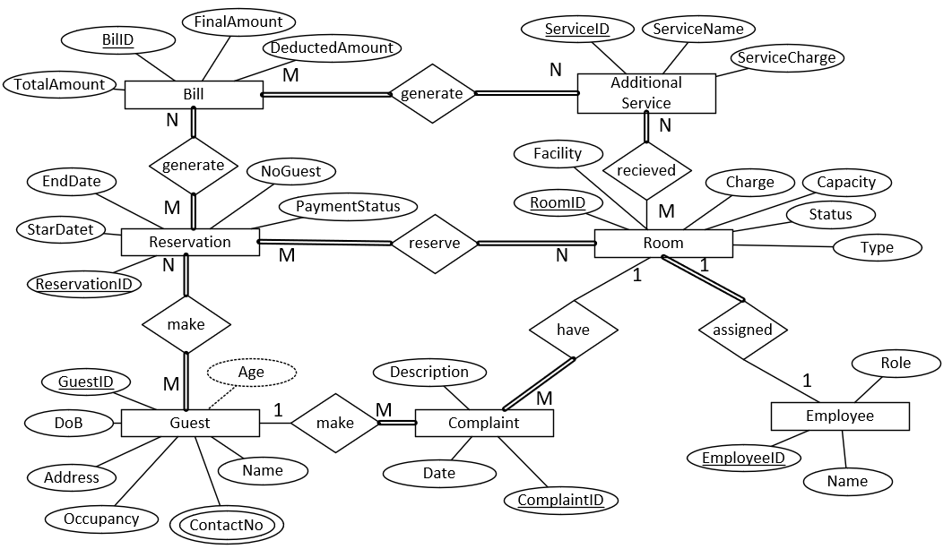
Figure 1: ER Diagram

Assumptions:
- Guests can have one or more contact number.
- A guest can have multiple reservations, but each reservation is tied to single guest.
- A guest can make multiple complaints. Each complaint is tied to a specific guest and includes a Description and Date.
- A final bill is generated at check-out, summarizing all Charges including room Charges and additional services.
- A guest can reserve multiple rooms, and each reservation is treated as a separated reservation entry.
- Employees can serve multiple rooms, and each room can have multiple assigned employees.

Task 1.2

User and System Requirements and tables for the Hotel Management System

User Requirements:
- Record all data about guests, bills, reservations, complaints, rooms, additional services and employees.
- Add information when needed.
- Edit the information as needed.
- Delete information when necessary.
- Organized record keeping.

System Requirements:
- A person with knowledge of databases is required to maintain the database.
- A computer with the following software and hardware specifications is required.
2.6 GHz or faster 64-bit processor.
Minimum of 4 GB of RAM.
Minimum of 10 GB hard disk space.
Operating system should be windows 7 or above.
- SQL Server Management Studio application.

tables for the above designed ER diagram

GuestID (PK) | Name | ContactNo | Occupancy | DoB | Address | Age
G001 | Roy | 0754419999  0774856244 | Yes | 1-2-2000 | 12 Main St, NY 10001 | 24
G002 | Malik | 0756894421 | Yes | 2-5-1992 | 34 Oak St, LA 90001 | 32
G003 | Ahsan | 0716569826 | Yes | 9-5-1999 | 56 Pine Ln, TX 73301 | 25
G004 | Alice | 0726581568 | Yes | 1-6-2006 | 78 Birch Rd, IL 60601 | 18
G005 | Dori | 0704205128 | Yes | 2-6-2005 | 43 Willow Ln, OR 97205 | 19
guest table
Table 2: Guest table
room table
RoomID (PK) | Facility | Type | Charge | Capacity | Status
R001 | 1chair, 1bed | single | 500.00 | 1 | Vacant
R002 | 1chair, 1bed | single | 500.00 | 1 | Occupied
R003 | 2bed, 2chair | double | 2000.00 | 2 | Vacant
R004 | 2bed, 2chair | double | 2000.00 | 2 | Vacant
R005 | AC, 5bed, 5chair | family | 5000.00 | 5 | Vacant
Table 3: Room table
Reservation table
ReservationID (PK) | GuestID (FK) | RoomID (FK) | StartDate | EndDate | NoGuest | PaymentStatus
RES01 | G001 | R001 | 2023-06-01 | 2023-06-05 | 1 | Paid
RES02 | G002 | R002 | 2023-06-03 | 2023-06-07 | 1 | Paid
RES03 | G003 | R003 | 2023-06-02 | 2023-06-06 | 2 | Paid
RES04 | G004 | R004 | 2023-06-04 | 2023-06-08 | 2 | Paid
RES05 | G005 | R005 | 2023-06-05 | 2023-06-09 | 4 | Paid
Table 4: reservation table

Employee table
EmployeeID (PK) | RoomID (FK) | Name | Role
E001 | R001 | Marcus | room boy
E002 | R002 | Shan | room boy
E003 | R003 | John | room boy
E004 | R004 | Edna | waitress
E005 | R005 | Evana | waitress
Table 5: Employee table
ServiceID (PK) | RoomID (FK) | ServiceName | ServiceCharge
SER001 | R001 | Laundry | 200.00
SER002 | R002 | RoomService | 100.00
SER003 | R003 | Spa | 500.00
SER004 | R004 | Gym | 150.00
SER005 | R005 | Breakfast | 50.00
Additional Service table
Table 6: Additional Service table
Bill table
BillID (PK) | ServiceID (FK) | ReservationID (FK) | TotalAmount | DeductedAmount | FinalAmount
B01 | SER001 | RES01 | 700.00 | 100.00 | 600.00
B02 | SER002 | RES02 | 1100.00 | 100.00 | 1000.00
B03 | SER003 | RES03 | 2500.00 | 100.00 | 2400.00
B04 | SER004 | RES04 | 3150.00 | 100.00 | 3050.00
B05 | SER005 | RES05 | 5050.00 | 100.00 | 4950.00
Table 7: Bill table
Complaint table
ComplaintID (PK) | GuestID (FK) | RoomID (FK) | Description | Date
C001 | G001, G007 | R001 | Room not clean | 2023-06-01
C002 | G002 | R002 | No hot water | 2023-06-03
C003 | G003 | R003 | Bad food quality | 2023-06-02
C004 | G004 | R004 | No cold water | 2023-06-04
C005 | G005, G008 | R005 | AC not working | 2023-06-05
Table 8: Complaint table

Data validation for the tables
For the above tables we created, we should give appropriate data Types for the values.
- We can give char data Type for the values of the attributes like GuestID, RoomID, ReservationID, EmployeeID, ServiceID, BillID, ComplaintID.
- We can give varchar data Type for the values like Name of guest, Address, room Facility, room Type, room Status, payment Status, Name of employee, Role of employee, service Name and complaint Description.
- We can give int data Type for the values like contact number, room Capacity, number of guests.
- We can give Date data Type for the values like Date of birth of guest and reservation start and end Date.
- We can give currency data Type for the values like service Charge, deducted amount, total amount and final amount.

b. Applying the Normalization rules on the above created tables up to third normal form(3NF).

Database normalization is a method for structuring data within a database to guarantee clear and accurate results. This fundamental concept in relational databases can involve duplicating information and creating extra tables. (Margaret Rouse, 2019)

1.Guest table
GuestID (PK) | Name | ContactNo | Occupancy | DoB | Address | Age
G001 | Roy | 0754419999  0774856244 | Yes | 1-2-2000 | 12 Main St, NY 10001 | 24
G002 | Malik | 0756894421 | Yes | 2-5-1992 | 34 Oak St, LA 90001 | 32
G003 | Ahsan | 0716569826 | Yes | 9-5-1999 | 56 Pine Ln, TX 73301 | 25
G004 | Alice | 0726581568 | Yes | 1-6-2006 | 78 Birch Rd, IL 60601 | 18
G005 | Dori | 0704205128 | Yes | 2-6-2005 | 43 Willow Ln, OR 97205 | 19
Table 9: Unnormalized guest table

Step 1: First Normal Form (1NF)
Rules:
- There are no repeating or duplicate fields.
- Each cell contains only a single value.

In the guest table there are muti-values. So, we have to separate them into new rows.
GuestID (PK) | Name | ContactNo | Occupancy | DoB | Address | Age
G001 | Roy | 0754419999 | Yes | 1-2-2000 | 12 Main St, NY 10001 | 24
G001 | Roy | 0774856244 | Yes | 1-2-2000 | 12 Main St, NY 10001 | 24
G002 | Malik | 0756894421 | Yes | 2-5-1992 | 34 Oak St, LA 90001 | 32
G003 | Ahsan | 0716569826 | Yes | 9-5-1999 | 56 Pine Ln, TX 73301 | 25
G004 | Alice | 0726581568 | Yes | 1-6-2006 | 78 Birch Rd, IL 60601 | 18
G005 | Dori | 0704205128 | Yes | 2-6-2005 | 43 Willow Ln, OR 97205 | 19
Table 10: 1NF guest table

Step 2: Second Normal Form (2NF)
Rules:
- All non-key fields depend on all components of the primary key.

In our latest normalized room table, not all non-key fields depend on all components of the primary key. In order to that we have to normalize this table to 2NF. To do this we have separate the table into two tables.

Guest table
GuestID (PK) | Name | Occupancy | DoB | Address | Age
G001 | Roy | Yes | 1-2-2000 | 12 Main St, NY 10001 | 24
G001 | Roy | Yes | 1-2-2000 | 12 Main St, NY 10001 | 24
G002 | Malik | Yes | 2-5-1992 | 34 Oak St, LA 90001 | 32
G003 | Ahsan | Yes | 9-5-1999 | 56 Pine Ln, TX 73301 | 25
G004 | Alice | Yes | 1-6-2006 | 78 Birch Rd, IL 60601 | 18
G005 | Dori | Yes | 2-6-2005 | 43 Willow Ln, OR 97205 | 19

Table 11: Guest table

Guest contacts table
GuestID (PK) | ContactNo (PK)
G001 | 0754419999
G001 | 0774856244
G002 | 0756894421
G003 | 0716569826
G004 | 0726581568
G005 | 0704205128

Table 12: Guest contacts table

Step 3: Third normal form (3NF)
Rules:
- No non-key field depends upon another.
In our latest normalized guest table, no non-key field depends upon each other. In order to that we don’t have to normalized this table. Its already in 3NF.

2.room table
RoomID (PK) | Facility | Type | Charge | Capacity | Status
R001 | 1chair, 1bed | Single | 500.00 | 1 | Vacant
R002 | 1chair, 1bed | single | 500.00 | 1 | Occupied
R003 | 2bed, 2chair | double | 2000.00 | 2 | Vacant
R004 | 2bed, 2chair | double | 2000.00 | 2 | vacant
R005 | AC, 5bed, 5chair | family | 5000.00 | 5 | Vacant
Table 13: unnormalized room table
Step 1: First Normal Form (1NF)
Rules:
- There are no repeating or duplicate fields.
- Each cell contains only a single value.

In the room table there are multi-values. We have to separate them into new rows.
RoomID (PK) | Facility | Type | Charge | Capacity | Status
R001 | 1chair | single | 500.00 | 1 | Vacant
R001 | 1bed | single | 500.00 | 1 | Vacant
R002 | 1chair | single | 500.00 | 1 | Occupied
R002 | 1bed | single | 500.00 | 1 | Occupied
R003 | 2bed | double | 2000.00 | 2 | Vacant
R003 | 2chair | double | 2000.00 | 2 | Vacant
R004 | 2bed | double | 2000.00 | 2 | Vacant
R004 | 2chair | double | 2000.00 | 2 | Vacant
R005 | AC | family | 5000.00 | 5 | Vacant
R005 | 5bed | family | 5000.00 | 5 | Vacant
R005 | 5chair | family | 5000.00 | 5 | Vacant
Table 14: 1NF room table

Step 2: Second Normal Form (2NF)
Rules:
- All non-key fields depend on all components of the primary key.

In our latest normalized room table, not all non-key fields depend on all components of the primary key. In order to that we have to normalize this table to 2NF. To do this we have separate the table into two tables.
room Facility
RoomID (PK) | Facility (PK)
R001 | 1chair
R001 | 1bed
R002 | 1chair
R002 | 1bed
R003 | 2bed
R003 | 2chair
R004 | 2bed
R004 | 2chair
R005 | AC
R005 | 5bed
R005 | 5chair
Table 15: 2NF room table (facility)
room
RoomID (PK) | Type | Charge | Capacity | Status
R001 | single | 500.00 | 1 | vacant
R002 | single | 500.00 | 1 | occupied
R003 | double | 2000.00 | 2 | vacant
R004 | double | 2000.00 | 2 | vacant
R005 | family | 5000.00 | 5 | vacant
Table 16: 2NF room table (room)

Step 3: Third normal form (3NF)
Rules:
- No non-key field depends upon another.

In our latest normalized room table, some non-key fields are depending upon each other. So, we have to separate the room detail table into two tables. We have to normalize the table like below.
room Facility
RoomID (PK) | Facility (PK)
R001 | 1chair
R001 | 1bed
R002 | 1chair
R002 | 1bed
R003 | 2bed
R003 | 2chair
R004 | 2bed
R004 | 2chair
R005 | AC
R005 | 5bed
R005 | 5chair
Table 17: 3NF room table (facility)
room
RoomID (PK) | Type | Status
R001 | single | vacant
R002 | single | occupied
R003 | double | vacant
R004 | double | vacant
R005 | family | vacant
Table 18: 3NF room table (room)
room detail
Type (PK) | Charge | Capacity
single | 500.00 | 1
double | 2000.00 | 2
family | 5000.00 | 5
Table 19: 3NF room table (room detail)
3.reservation table
ReservationID (PK) | GuestID (FK) | RoomID (FK) | StartDate | EndDate | NoGuest | PaymentStatus
RES01 | G001 | R001 | 2023-06-01 | 2023-06-05 | 1 | Paid
RES02 | G002 | R002 | 2023-06-03 | 2023-06-07 | 1 | Paid
RES03 | G003 | R003 | 2023-06-02 | 2023-06-06 | 2 | Paid
RES04 | G004 | R004 | 2023-06-04 | 2023-06-08 | 2 | Paid
RES05 | G005 | R005 | 2023-06-05 | 2023-06-09 | 4 | Paid
Table 20: unnormalized reservation table
In this reservation table, we don’t need to use any normalization method. Because, its already in the 3rd normal form.

4.employee table
EmployeeID (PK) | RoomID (FK) | Name | Role | AssignedRoom
E001 | R001 | Marcus | room boy | 101
E002 | R002 | Shan | room boy | 102
E003 | R003 | John | room boy | 103
E004 | R004 | Edna | waitress | 104
E005 | R005 | Evana | waitress | 105
Table 21: unnormalized employee table
In this employee table, we don’t need to use any normalization method. Because, its already in the 3rd normal form.

5.additional services table
ServiceID (PK) | RoomID (FK) | ServiceName | ServiceCharge
SER001 | R001 | Laundry | 200.00
SER002 | R002 | RoomService | 100.00
SER003 | R003 | Spa | 500.00
SER004 | R004 | Gym | 150.00
SER005 | R005 | Breakfast | 50.00
Table 22: unnormalized additional service table

In this additional services table, we don’t need to use any normalization method. Because, its already in the 3rd normal form.

6.bill table
BillID (PK) | ServiceID (FK) | ReservationID (FK) | TotalAmount | DeductedAmount | FinalAmount
B01 | SER001 | RES01 | 700.00 | 100.00 | 600.00
B02 | SER002 | RES02 | 1100.00 | 100.00 | 1000.00
B03 | SER003 | RES03 | 2500.00 | 100.00 | 2400.00
B04 | SER004 | RES04 | 3150.00 | 100.00 | 3050.00
B05 | SER005 | RES05 | 5050.00 | 100.00 | 4950.00
Table 23: unnormalized bill table
In this bill table we don’t need to use any normalization method. Because, its already in the 3rd normal form.

7.complaint table
ComplaintID (PK) | GuestID (FK) | RoomID (FK) | Description | Date
C001 | G001 | R001 | Room not clean | 2023-06-01
C002 | G002 | R002 | No hot water | 2023-06-03
C003 | G003 | R003 | Bad food quality | 2023-06-02
C004 | G004 | R004 | No cold water | 2023-06-04
C005 | G005 | R005 | AC not working | 2023-06-05
Table 24: unnormalized complaint table

In this additional services table, we don’t need to use any normalization method. Because, its already in the 3rd normal form.

Task 2

2.1 Develop the physical relational database with MSSQL Server and identifying and assigning primary and foreign keys properly.

1. Create the Database
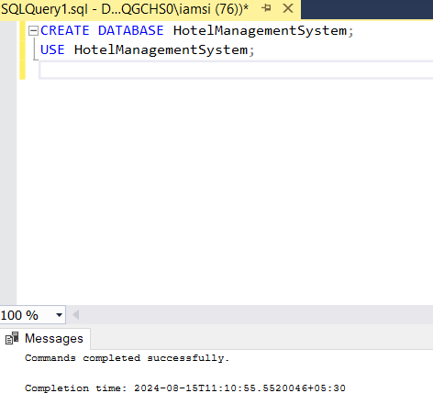
Figure 2:create database
2. Create the Guest Table
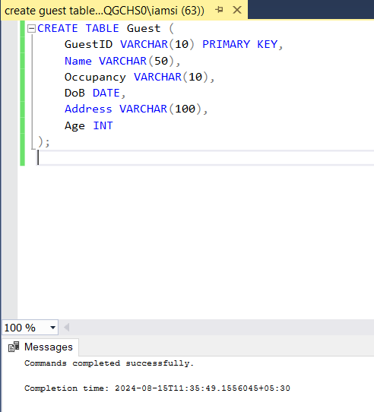
Figure 3:create guest table
3. Create the Guest Contacts Table
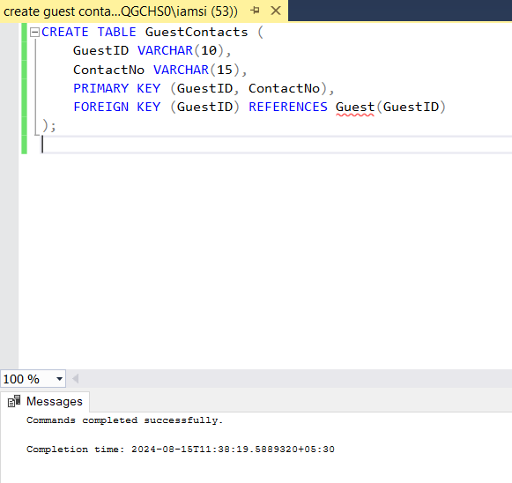
Figure 4:create guest contacts table
4. Create the RoomFacility Table
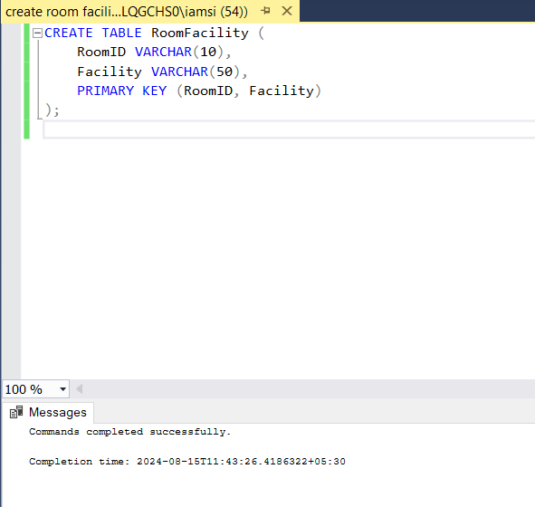
Figure 5:create room facility table
5. Create the Room Table
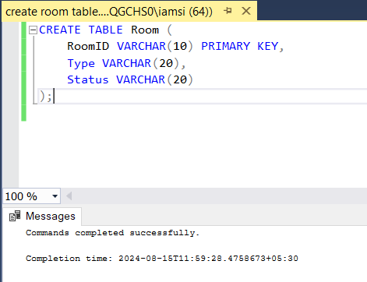
Figure 6:create room table
6. Create the RoomDetail Table
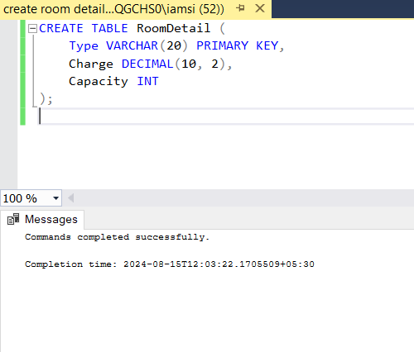
Figure 7: create room detail table

7. Create the Reservation Table
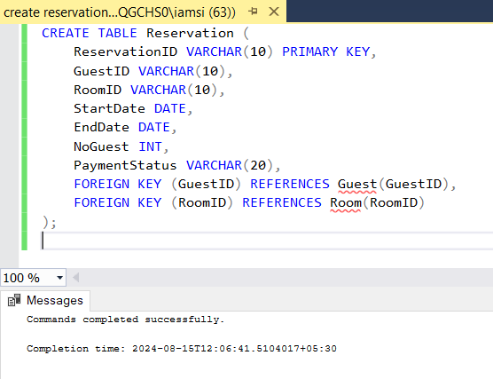
Figure 8:create reservation table
8. Create the Employee Table
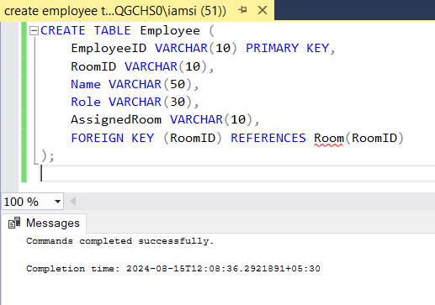
Figure 9:create employee table

9. Create the AdditionalServices Table
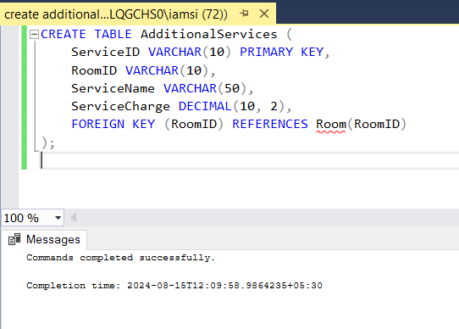
Figure 10: create additional services table
10. Create the Bill Table
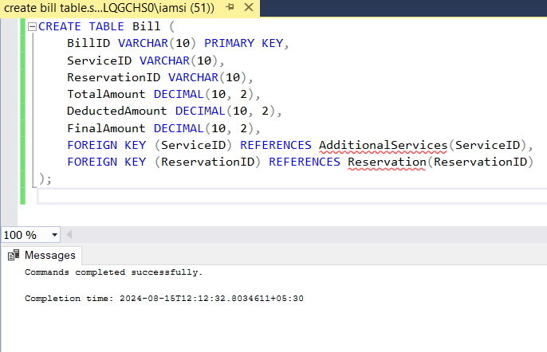
Figure 11:create bill table

11. Create the Complaints Table
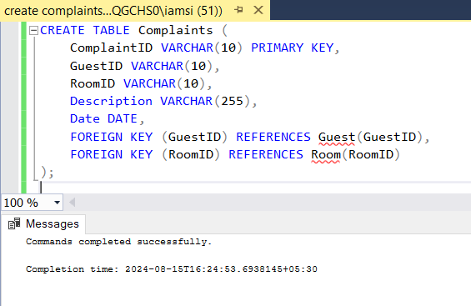
Figure 12:create complaint table

2.2. Implement the query language to insert data to the above created tables
1. Insert Data into the Guest Table
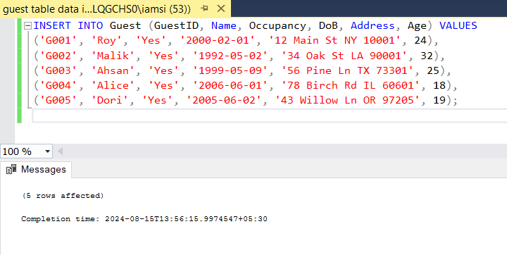
Figure 13:insert data into guest table

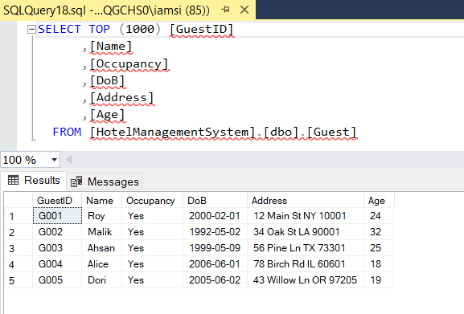
Figure 14:viewing inserted data in guest table

2. Insert Data into the GuestContacts Table
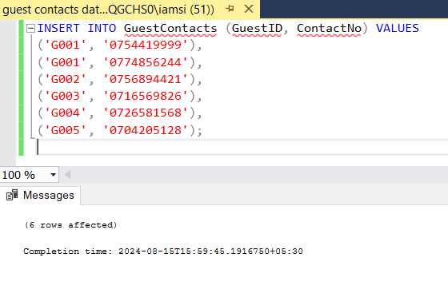
Figure 15:insert data into the guest contacts table

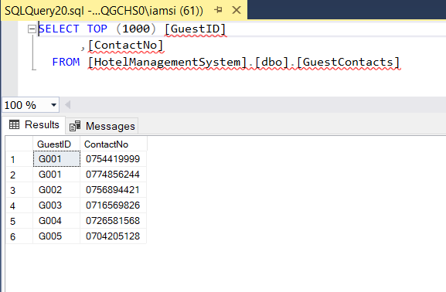
Figure 16: viewing inserted data into the guest contacts table

3. Insert Data into the RoomFacility Table
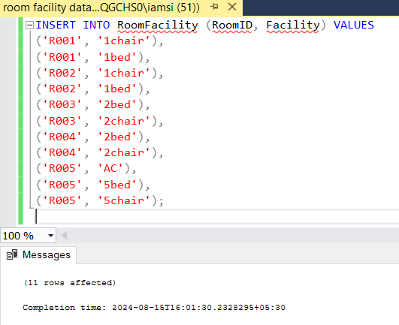
Figure 17:insert data into room facility table

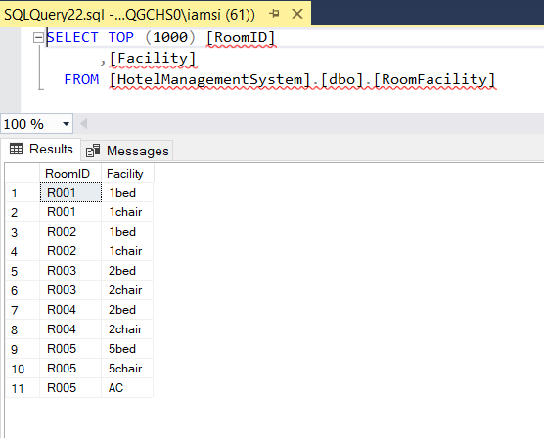
Figure 18: viewing inserted data into the room facility table

4. Insert Data into the Room Table
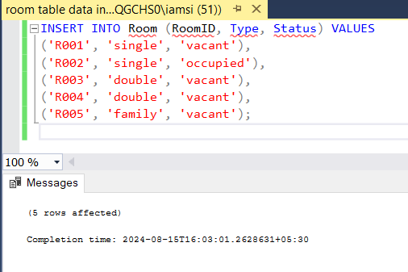
Figure 19:insert data into the room table

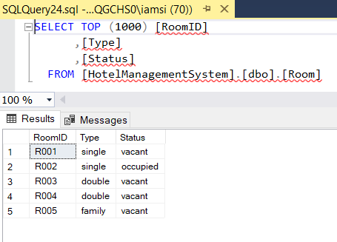
Figure 20:viewing inserted data into the room table

5. Insert Data into the RoomDetail Table
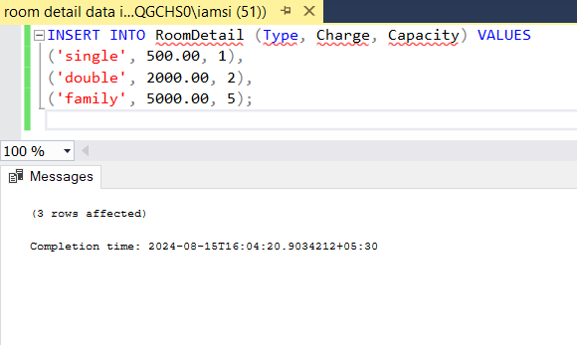
Figure 21:insert data into the room detail table

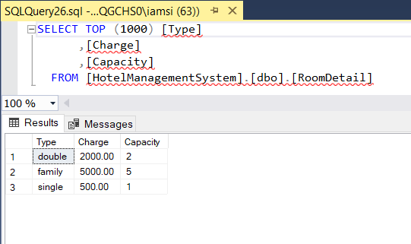
Figure 22:viewing data into the room detail table

6. Insert Data into the Reservation Table
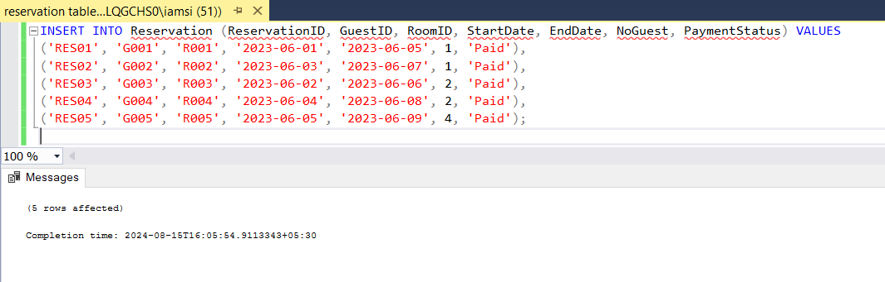
Figure 23:insert data into the reservation table

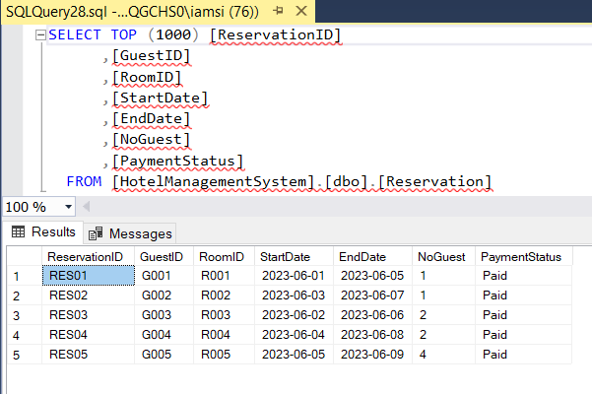
Figure 24:viewing data into the reservation table

7. Insert Data into the Employee Table
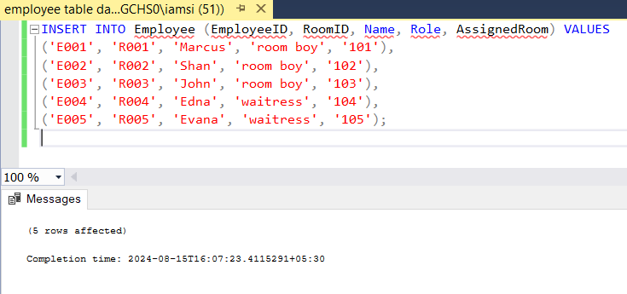
Figure 25:inserting data into the employee table

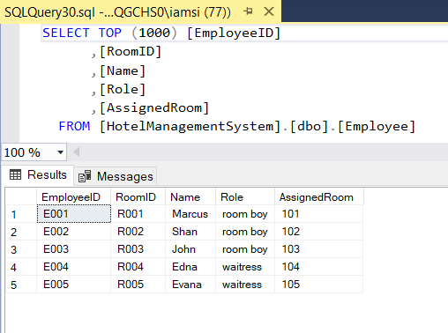
Figure 26: viewing data into the employee table

8. Insert Data into the AdditionalServices Table
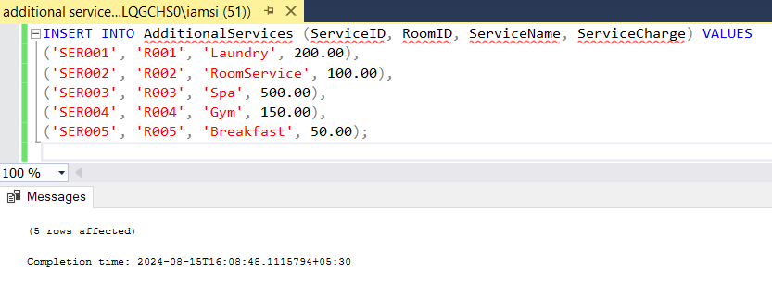
Figure 27: insert data into the additional services table

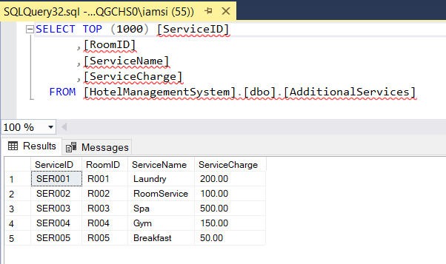
Figure 28:viewing data into the additional services table

9. Insert Data into the Bill Table
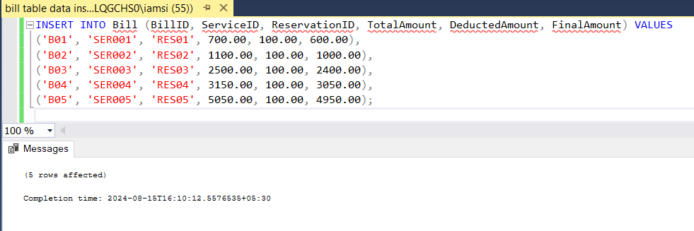
Figure 29: insert data into the bill table

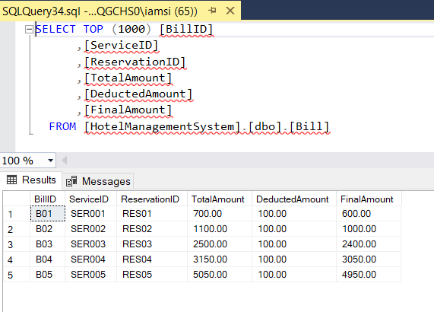
Figure 30:viewing inserted data into the bill table

10. Insert Data into the Complaints Table
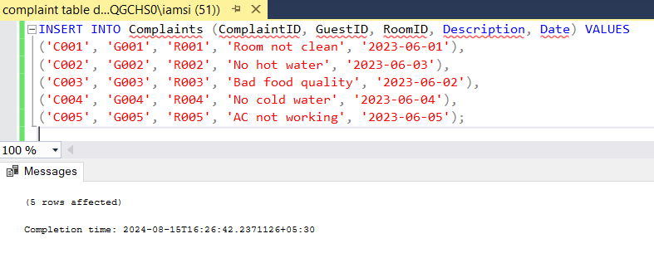
Figure 31:insert data into the complaint table

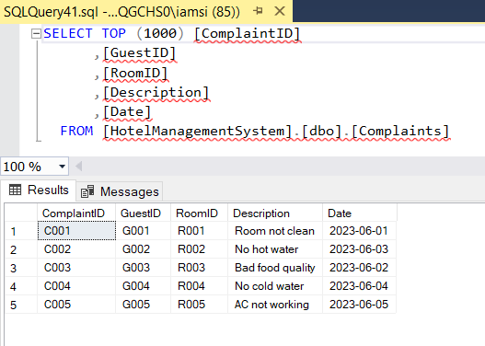
Figure 32:viewing inserted data into the complaint table

apply the queries to update and delete.

1. Update a Guest's Address
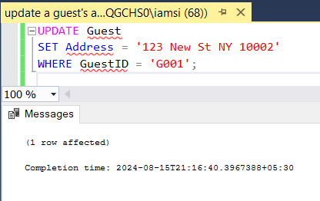
Figure 33:update a guest's address

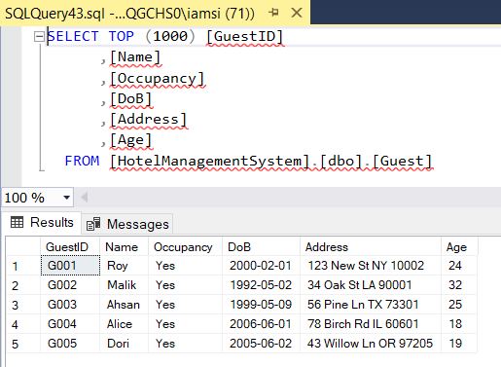
Figure 34:after update the guest's address

2. Update an Employee's Role
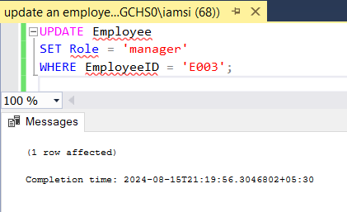
Figure 35:update an employee's role

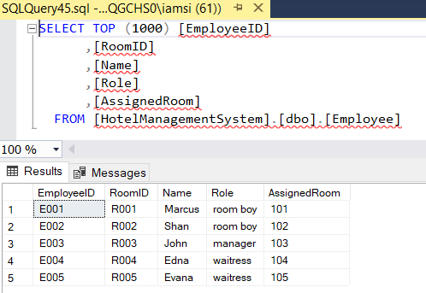
Figure 36:after update the employee's role

3. Update Room Status
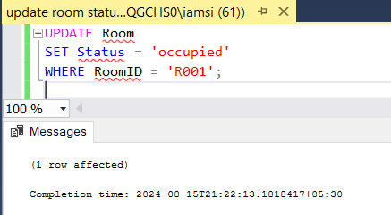
Figure 37:update room status

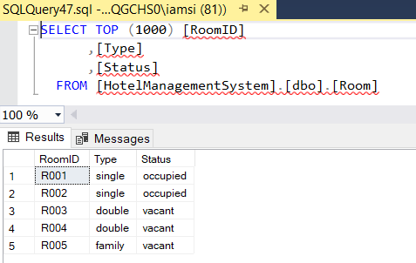
Figure 38:after update the room status

4. Delete a Room Facility
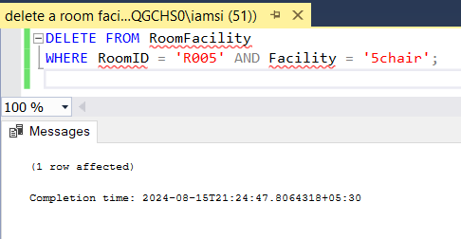
Figure 39:delete a room facility

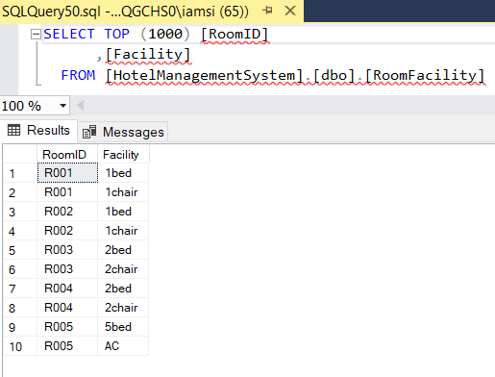
Figure 40:after delete the room facility

5. delete a complaint
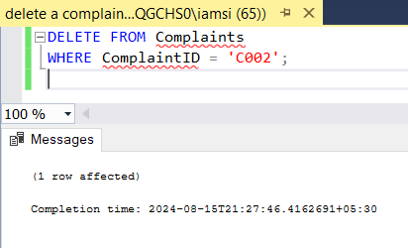
Figure 41:delete a complaint

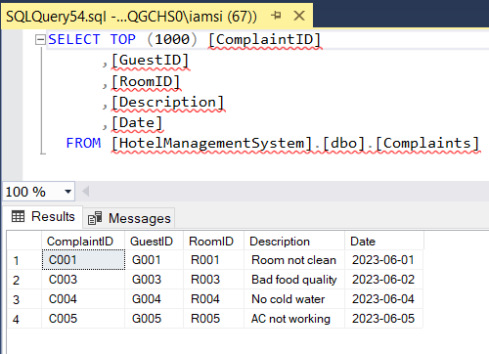
Figure 42:after delete the complaint

2.3. retrieve meaningful data using different types of complex queries.

1. JOIN
Retrieve a list of guests along with the rooms they have reserved.
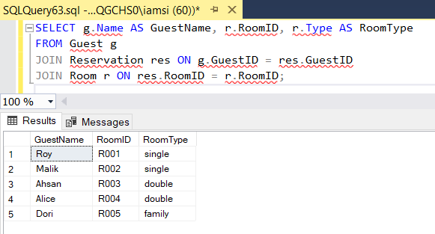
Figure 43:using join query

2. Subquery
Find all guests who have made a reservation in a room that costs more than $2000.
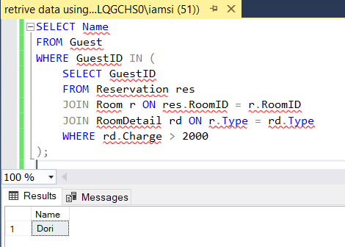
Figure 44:using subquery

3. Aggregation
Calculate the total number of complaints per guest.
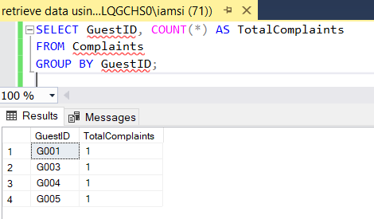
Figure 45:using aggregation query

4. Set Operator (UNION)
Retrieve all unique room IDs either from the RoomFacility table or the Employee table.
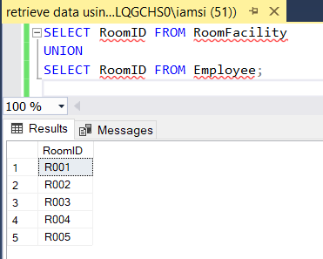
Figure 46:using set operator

5. Unspecified WHERE Clause
Retrieve all reservations where the payment status is not specified (assuming NULL or empty string indicates unspecified).
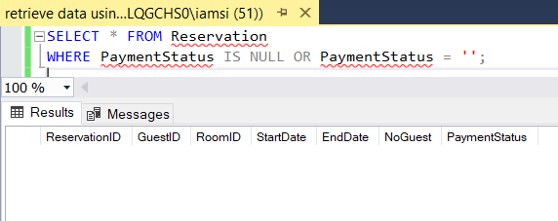
Figure 47:using unspecified where clause

6. Substring Comparison
Find all guests whose names start with the letter 'A'.
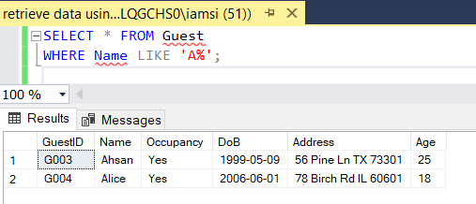
Figure 48:using substring comparison

7. Arithmetic Operator
Calculate the final amount after a 10% discount on the total amount in the Bill table
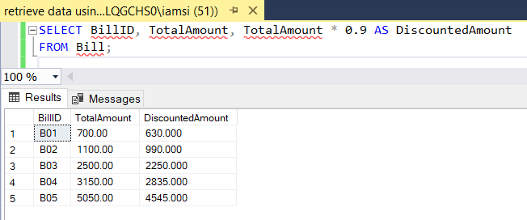
Figure 49:using arithmetic operator

8. Wildcard
Select all columns from the Room table where the room status is 'vacant'.
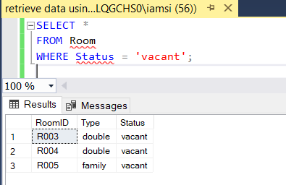
Figure 50:using wild card

Task 3

test the developed database system against user and system requirements.

Database testing
Database testing is a process that verifies the structure and content of a database. It involves examining components like schemas, tables, and triggers to ensure data accuracy and reliability. Additionally, it tests the database's performance under heavy loads by running complex queries. (Hamilton, 2024)

Types of Database testing
1. Whitebox database testing
White box testing is a method of examining the internal workings of a database. It involves testing the database's underlying structure, including tables, data models, and how different parts interact. This type of testing requires in-depth knowledge of the database and its code.

Testers look at elements like database triggers, views, and SQL queries to ensure they function correctly. They check for errors in the database's logic and structure. While it's effective at finding internal problems, it doesn't directly test how well the database responds to user actions.

2. Blackbox database testing
Black box testing focuses on checking how a database works from a user's perspective without looking at its internal code. Testers examine how data enters and leaves the database, ensuring it matches expected results. Various techniques are used to design test cases, such as considering different input values and their potential outcomes. This type of testing is done early in development and is generally less expensive than other testing methods. However, it may miss certain types of errors and doesn't provide complete coverage of the database's functionality. (Chand, 2023)

There are many types of Blackbox testing. But, we are going to use these 2 types for testing:
1. Equivalence class Partitioning: Divides the input data into equivalent partitions, with each partition being regarded the same by the program. Testing one representative from each partition is usually enough to cover all potential scenarios.
2. Boundary Value Analysis: Tests the bounds of input ranges, as errors frequently arise on the edge of input limits.

Test Plan against developed database system

Objective:
To validate the functionality of the hotel management system's database, ensuring it meets the specified requirements for data recording, updating, deleting, and retrieving across various entities.

Test Methodologies:
- Equivalence Class Partitioning (ECP): Identify valid and invalid partitions of input data to ensure broad coverage.
- Boundary Value Analysis (BVA): Focus on edge values to validate system behavior at boundaries.

Main goals of our testing
- Guest details should be saved without any errors.
- Reservations should be made without any errors.
- Checking room status feature should be work properly.
- Bills should be generated without any errors.
- Complaints should be collected properly.
- Additional services should be save properly.

1. Equivalence Class Partitioning (ECP) Tests

A. ECP Based on Valid and Invalid Input Ranges

Guest Table
Description: This test validates input fields in the Guest table by testing both valid and invalid partitions. Age should be above 18 and name should be given.
Test ID | Test Case Description | Input Data | Expected Output | Type | Result
ECP-G-001 | Valid guest record | Name: Jane Doe, Age: 30, ContactNo: [555-9876] | Guest added successfully | ECP (Valid Input) | Passed
ECP-G-002 | Invalid guest record with empty Name | Name: "", Age: 30, ContactNo: [555-9876] | Error: Name is required | ECP (Invalid Input) | Passed
ECP-G-003 | Invalid age input | Name: Jane Doe, Age: -5, ContactNo: [555-9876] | Error: Invalid Age | ECP (Invalid Input) | Passed
Table 25:valid and invalid input test guest (ECP)

Reservation Table
Description: This test validates input fields in the Reservation table by testing both valid and invalid partitions.
Test ID | Test Case Description | Input Data | Expected Output | Type | Result
ECP-R-001 | Valid reservation | StartDate: 2024-08-16, EndDate: 2024-08-20 | Reservation created successfully | ECP (Valid Input) | Passed
ECP-R-002 | Invalid reservation with incorrect dates | StartDate: 2024-08-20, EndDate: 2024-08-16 | Error: End date must be after start date | ECP (Invalid Input) | Passed
Table 26:valid and invalid input test reservation (ECP)

Employee Table
Description: This table tracks employee details, including their roles and assigned rooms.
Test ID | Test Case Description | Input Data | Expected Output | Type | Result
ECP-E-001 | Valid employee record | Name: John Smith, Role: Manager, AssignedRoom: 101 | Employee added successfully | ECP (Valid Input) | Passed
ECP-E-002 | Invalid employee record with missing name | Name: "", Role: Manager, AssignedRoom: 101 | Error: Employee name is required | ECP (Invalid Input) | Passed
ECP-E-003 | Invalid role input | Name: John Smith, Role: "", AssignedRoom: 101 | Error: Role is required | ECP (Invalid Input) | Passed
Table 27:ECP based on valid and invalid input ranges in employee

B. ECP Based on Boolean Values

Room Table
Description: This test focuses on Boolean values, such as checking room availability.
Test ID | Test Case Description | Input Data | Expected Output | Type | Result
ECP-RM-001 | Check room availability (Available) | RoomID: R001, Status: Available | Room is available | ECP (Valid Input) | Passed
ECP-RM-002 | Check room availability (Unavailable) | RoomID: R001, Status: Unavailable | Room is unavailable | ECP (Valid Input) | Passed
Table 28:ECP based on Boolean in room table

Additional Service Table
Description: This test focuses on Boolean values related to the availability of additional services.
Test ID | Test Case Description | Input Data | Expected Output | Type | Result
ECP-AS-004 | Service available (Boolean) | ServiceName: Spa, Available: True | Service is available | ECP (Valid Input) | Passed
ECP-AS-005 | Service unavailable (Boolean) | ServiceName: Spa, Available: False | Service is unavailable | ECP (Valid Input) | Passed
Table 29:testing additional services ECP based on Boolean values

2. Boundary Value Analysis (BVA) Tests

A. BVA Based on Range of Values with Two Input Variables

Bill Table

Description: This test checks boundary values for the TotalAmount and DeductedAmount fields.
Test ID | Test Case Description | Input Data | Expected Output | Type | Result
BVA-B-001 | Test total amount at minimum | TotalAmount: 0, DeductedAmount: 0 | Bill generated successfully | BVA (Lower Boundary) | Passed
BVA-B-002 | Test total amount just below minimum | TotalAmount: -1, DeductedAmount: 0 | Error: Invalid total amount | BVA (Lower Boundary) | Passed
BVA-B-003 | Test deducted amount just above total | TotalAmount: 500, DeductedAmount: 501 | Error: Deducted amount cannot be greater than total amount | BVA (Upper Boundary) | Passed
Table 30:BVA based on range of values in billing
B. BVA of Equivalence Classes with One Input Variable

Guest Table
Description: This test examines boundary values within equivalence classes for the Age field.
Test ID | Test Case Description | Input Data | Expected Output | Type | Result
BVA-G-001 | Test age just below minimum | Age: 17 | Error: Age must be >= 18 | BVA (Lower Boundary) | Passed
BVA-G-002 | Test age at minimum | Age: 18 | Guest added successfully | BVA (Lower Boundary) | Passed
BVA-G-003 | Test age at upper limit | Age: 120 | Guest added successfully | BVA (Upper Boundary) | Passed
BVA-G-004 | Test age above upper limit | Age: 121 | Error: Invalid Age | BVA (Upper Boundary) | Passed
Table 31:BVA based on equivalence classes with one input in guest

C. Boundary Value Analysis (BVA) Based on Boolean Values

Complaint Table
Description: This test validates the boundary behaviour of Boolean fields (e.g., whether a complaint can be resolved or not).
Test ID | Test Case Description | Input Data | Expected Output | Type | Result
BVA-C-001 | Test logging of a valid complaint | Date: 2024-08-15, Description: Issue with AC | Complaint logged successfully | BVA (Valid Boolean Input) | Passed
BVA-C-002 | Test logging with missing description | Date: 2024-08-15, Description: NULL | Error: Description is required | BVA (Invalid Boolean Input) | Passed
Table 32:BVA based on Boolean values in complaint

Conclusion of Test Cases
The above tests cover various scenarios using ECP and BVA separately:
- ECP: Focuses on valid/invalid inputs and Boolean values.
- BVA: Concentrates on boundary values with single and multiple variables, as well as Boolean values.
A comprehensive database system is essential for Dickwella Beach Hotel and Resort to optimize its operations. This system effectively fulfils the hotel's needs by managing room bookings, guest details, reservations, services, billing, and customer complaints.
Thorough testing using Equivalence Class Partitioning and Boundary Value Analysis verified the system's performance under diverse conditions, identifying and resolving any issues. The database system has proven capable of handling the hotel's intricate operations, from initial booking to final payment. This robust solution will significantly improve efficiency and satisfaction for both staff and guests.

By structuring tests this way, we ensure comprehensive coverage of all critical aspects of the hotel management system's database. Each test case has been validated, and all test results passed, “confirming the system's behavior aligns with the specified requirements.”

Task 4

Task 4.1.

a. Technical user documentation for developed database system explaining how to use the database system.

Note: The documentation added within the folder. Please check the PDF formatted documentation.

Task 4.2

a. Produce a comprehensive design for the fully-functional database system, which includes user interface design.

1. Login interface
Purpose: The LoginForm is the entry point to the hotel management system. It is designed to authenticate users before they can access the main dashboard.
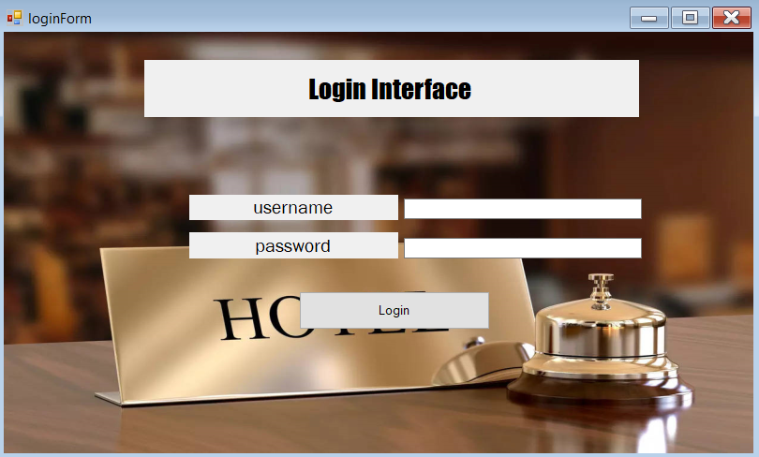
Figure 51:login interface

2. Main Dashboard
Purpose: The MainDashboardForm serves as the central hub of the hotel management system. It provides access to all management features like guest management, room management, and others.
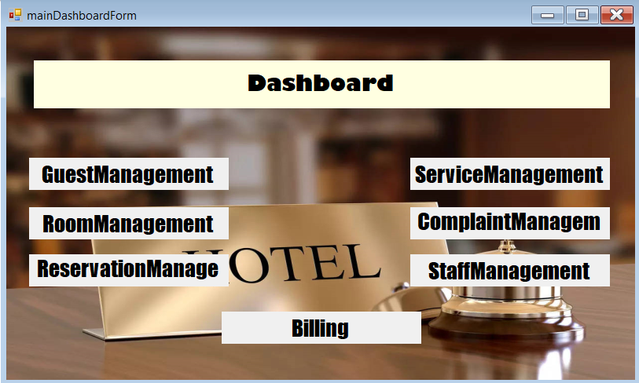
Figure 52:main dashboard
3. Guest Management
Purpose: The GuestManagementForm allows the hotel staff to add, update, or delete guest information. It also displays a list of all current guests.
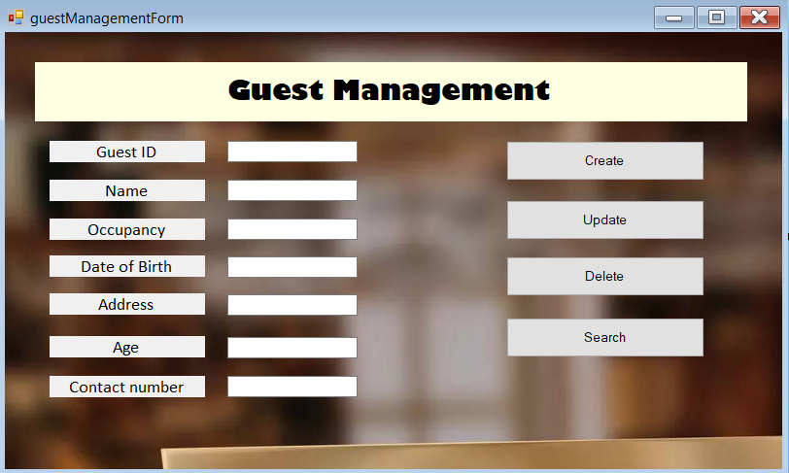
Figure 53:Guest management UI
4. Room Management
Purpose: The RoomManagementForm is used to manage the details of the hotel’s rooms, such as room type, status, charges, and other attributes.
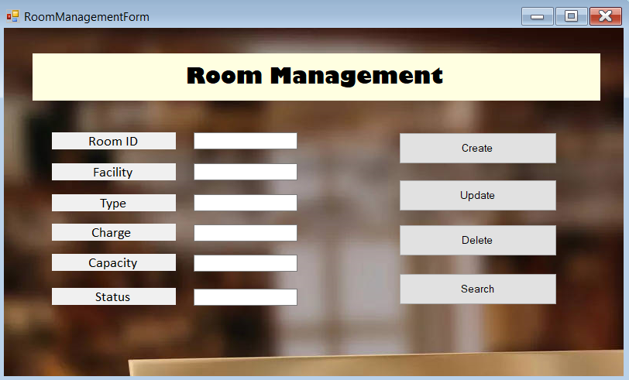
Figure 54:room management UI
5. Reservation Management
Purpose: The ReservationManagementForm handles all tasks related to managing guest reservations, including creating new reservations and viewing or editing existing ones.
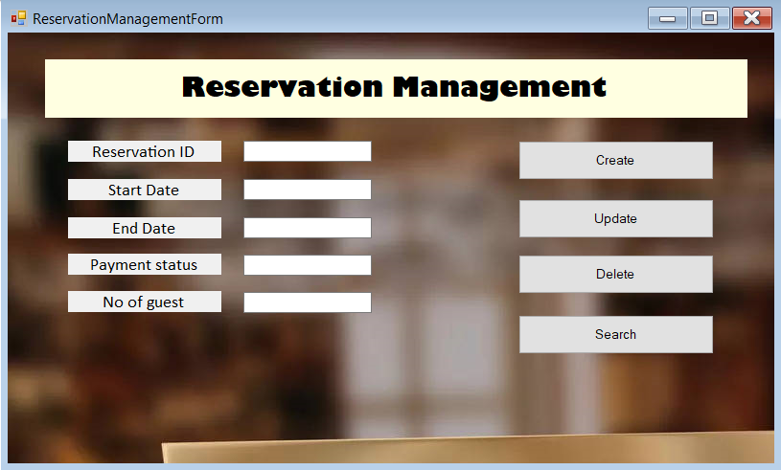
Figure 55:reservation management UI
6. Additional Service Management
Purpose: The ServiceManagementForm manages additional services provided by the hotel, such as spa, laundry, or room service. Staff can add new services, update existing ones, or remove services.
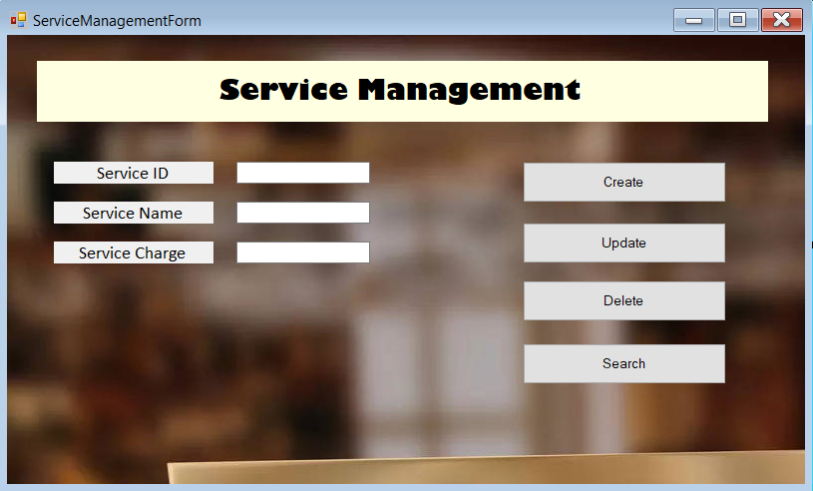
Figure 56:Additional services management UI
7. Employee Management
Purpose: The StaffManagementForm is used to manage the details of hotel staff, including their roles and room assignments.
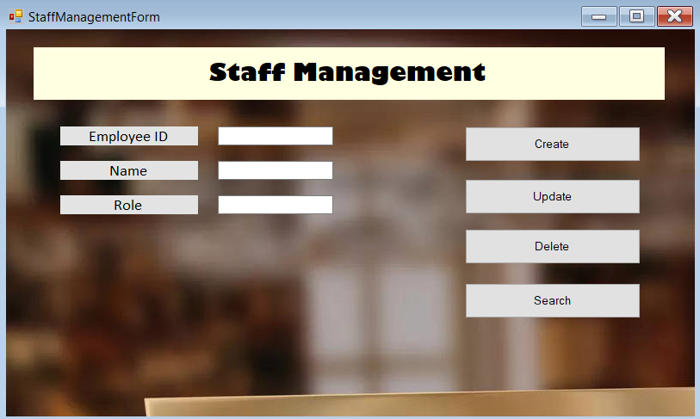
Figure 57:employee management UI
8. Complaint Management
Purpose: The ComplaintManagementForm manages guest complaints, allowing staff to record, update, and resolve complaints.
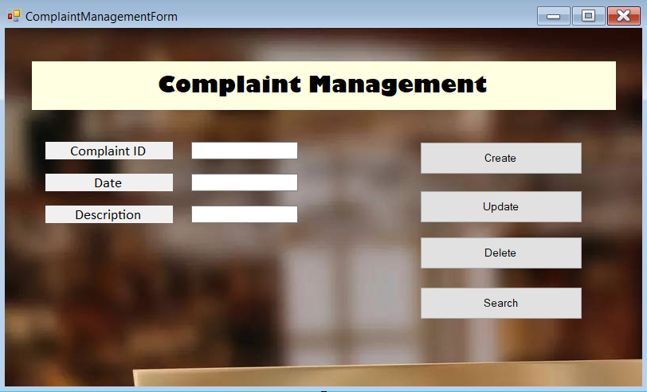
Figure 58:Complaint management UI
9. Billing
Purpose: The BillingForm is used to calculate and generate the final bill for a guest’s stay, including room charges, services, and any additional fees.
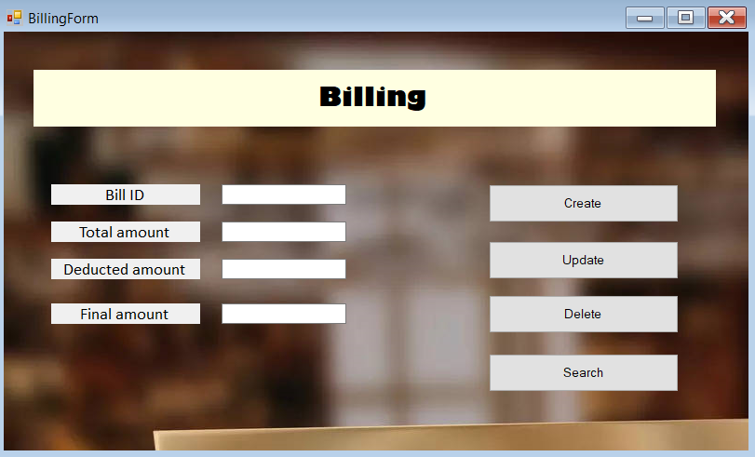
Figure 59:Billing Interface

Conclusion
In conclusion, the development of the hotel management system, as outlined in this project, demonstrates a comprehensive approach to managing various aspects of hotel operations through a structured and user-friendly interface. The system integrates several key functionalities, including user authentication, guest management, room management, reservation management, service management, staff management, complaint handling, and billing. Each module was carefully designed to streamline processes, reduce manual errors, and enhance the overall efficiency of hotel operations.

The implementation of the system using C# and Windows Forms ensures that it is robust and scalable, allowing for easy modifications and future enhancements as the hotel’s needs evolve. By utilizing a database-driven approach, the system maintains data integrity and provides quick access to information, which is crucial for effective decision-making.

Throughout this project, careful consideration was given to the user experience, with intuitive interfaces and straightforward navigation paths that enable staff to perform their duties with minimal training. The system's modular design also allows for easy integration with other hotel systems, offering the potential for further expansion.

Overall, this project serves as a practical application of software development principles in a real-world context, showcasing the importance of combining technical knowledge with an understanding of user requirements. The resulting system is a valuable tool that not only meets the current needs of the hotel but also lays a strong foundation for future technological advancements in hotel management.

